# Exercise: Media Queries

Problems for exercises and homework for the ["HTML and CSS" course @ SoftUni](https://softuni.bg/trainings/2983/html-and-css-may-2020). Submit your solutions in the SoftUni Judge system at <https://judge.softuni.bg/Contests/#!/List/ByCategory/134/HTML-and-CSS-Exercises>.

# Media Queries Playground

Create a web page like the following:

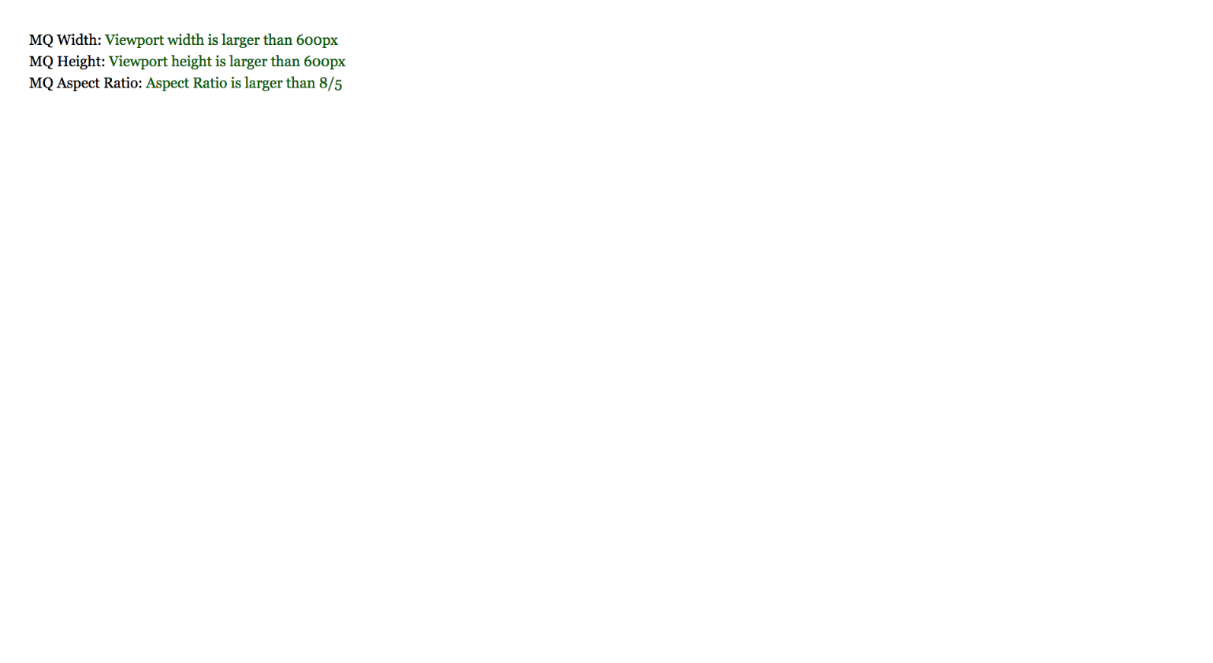

### Constraints

* Change the document **title** to "**Media Queries Playground"**
* Create three sections
  + Each section has span and after element
* In the span you must write the text before ":". The text **after** ":" will be in after element
* First section with class mq-width must contain text that will change based on width queries
  + Add a width media query to change the contents of the after elements when a query match
* Second section with class mq-height to contain text that will change based on height queries
  + Add a height media query to change the contents of the after elements when a query match
* Third section with class mq-ar to contain text that will change based on aspect ratio queries
  + Add an aspect ratio media query to change the contents of the after elements when a query match

## Media Queries in Typography

Upgrade your typograpgy.css file from previous homework’s with Media Queries. Create the following page for different screen sizes:

**Desktop:**

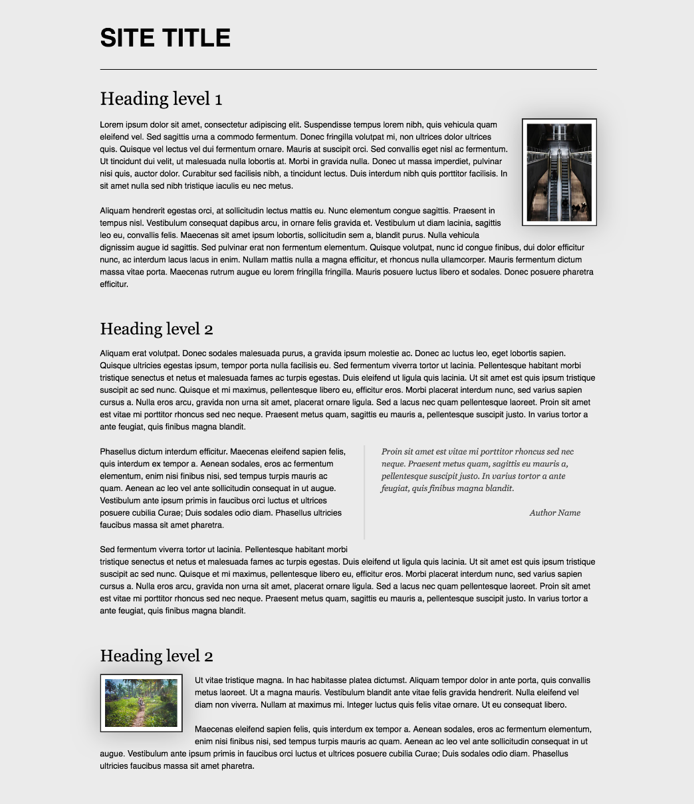

* Laptop

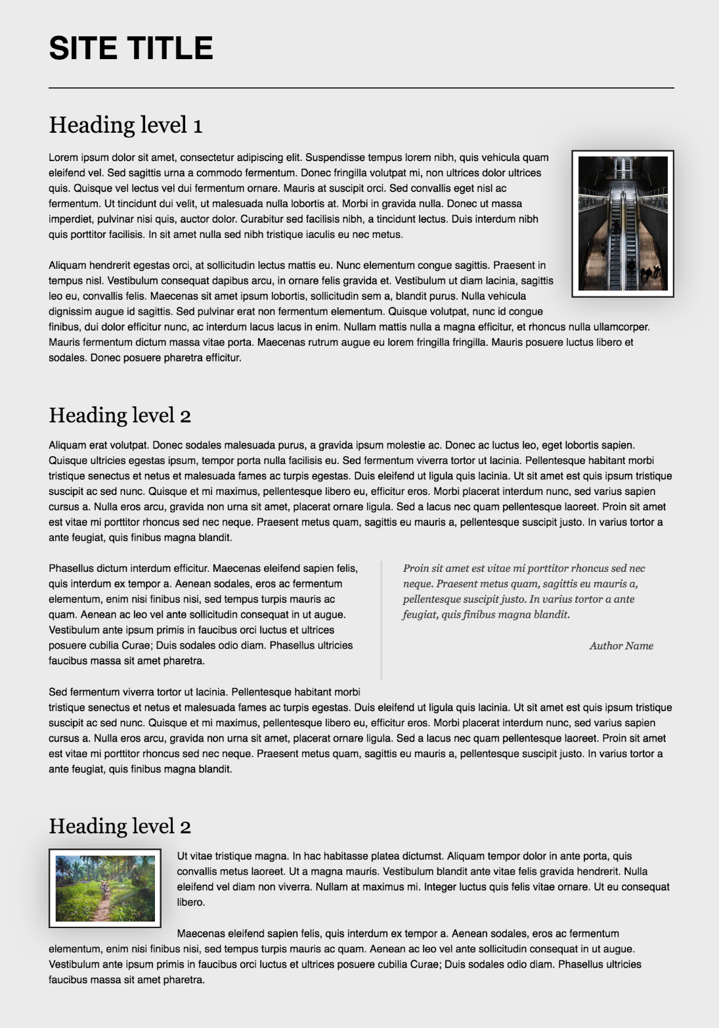

* Tablet

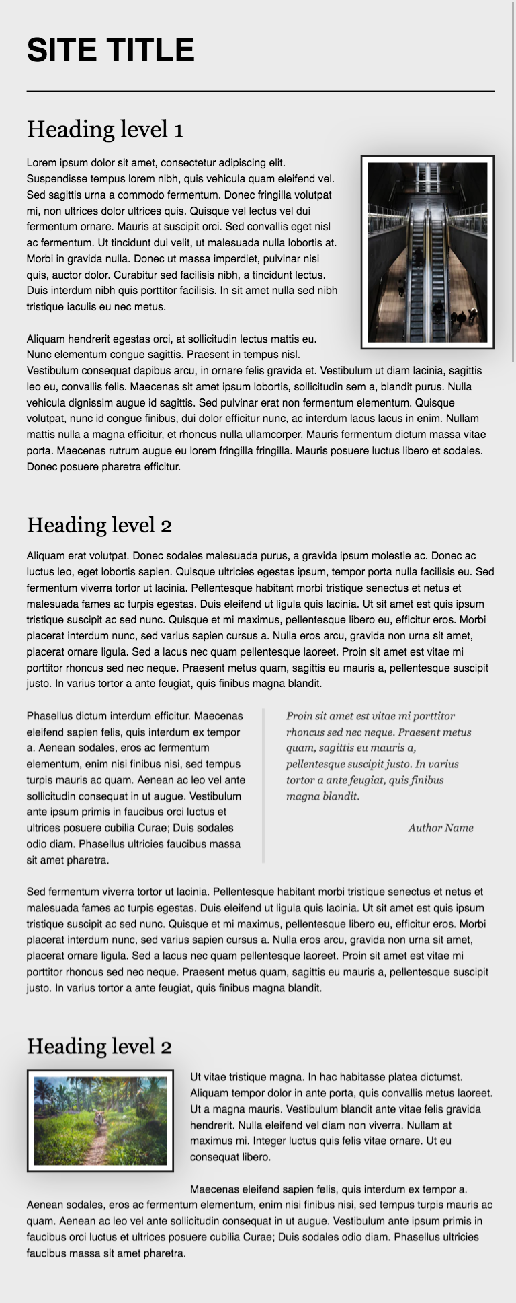

* Phone

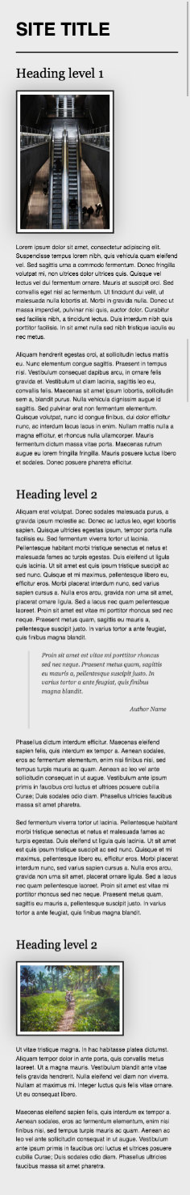

### Constraints

* Change the document **title** to "**Media Queries in Typography"**
* Make the font size for **phones** 12px
* Make the font size for screens **larger** than 500 14px
* Make the font size for screens **larger** than 600 16px
* Make the font size for screens **larger** than 800 18px
* Make the font size for screens **larger** than 1300 21px
* Make the font size for screens **larger** than 1800 23px

## Responsive Menu

Create a web page like the following:

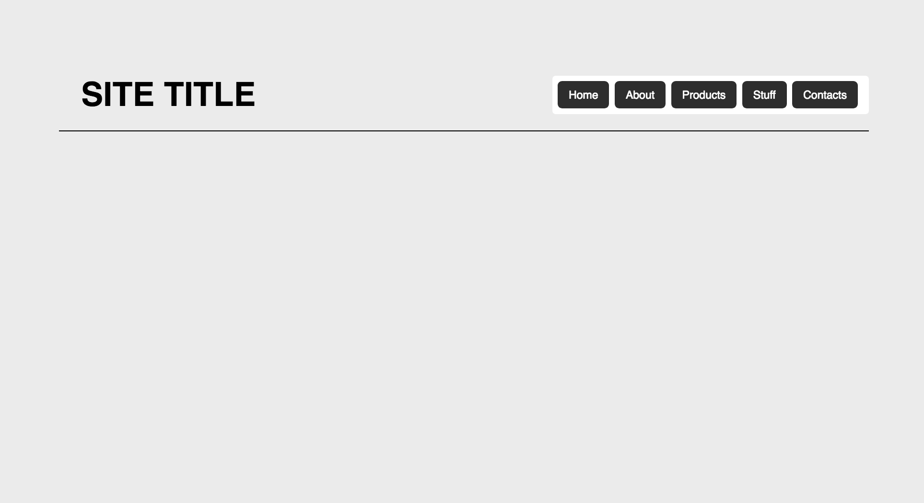

* Look at the provided screenshots in **resources** **folder** for different screen sizes view

### Constraints

* Change the document **title** to "**Responsive Menu"**
* Add media queries to **hide** the toggle checkbox and label for **desktops**
* Add media queries to **show** the toggle checkbox and label for **mobile devices**

## Update Blog Layout

Create a web page like the following:

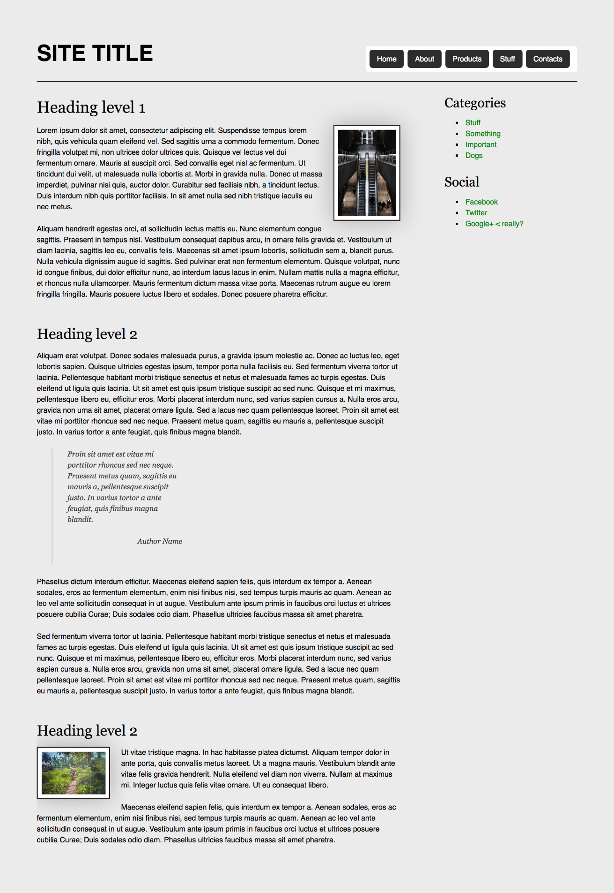

* Look at the provided screenshots in **resources** **folder** for different screen sizes view

### Constraints

* Change the document title to "**Update Blog Layout**"
* Copy the latest code from "**Blog layout with Flexbox**" exercise
* Copy your **multilevel dropdown**
* Make the menu **responsive**
* Get the latest typography.css
* Move the layout code to layout.css
* Move the navigation code to navigation.css
* Create reset.css file
* Include all CSS files from the main styles.css file

## Responsive Forms

Create a web page like the following:

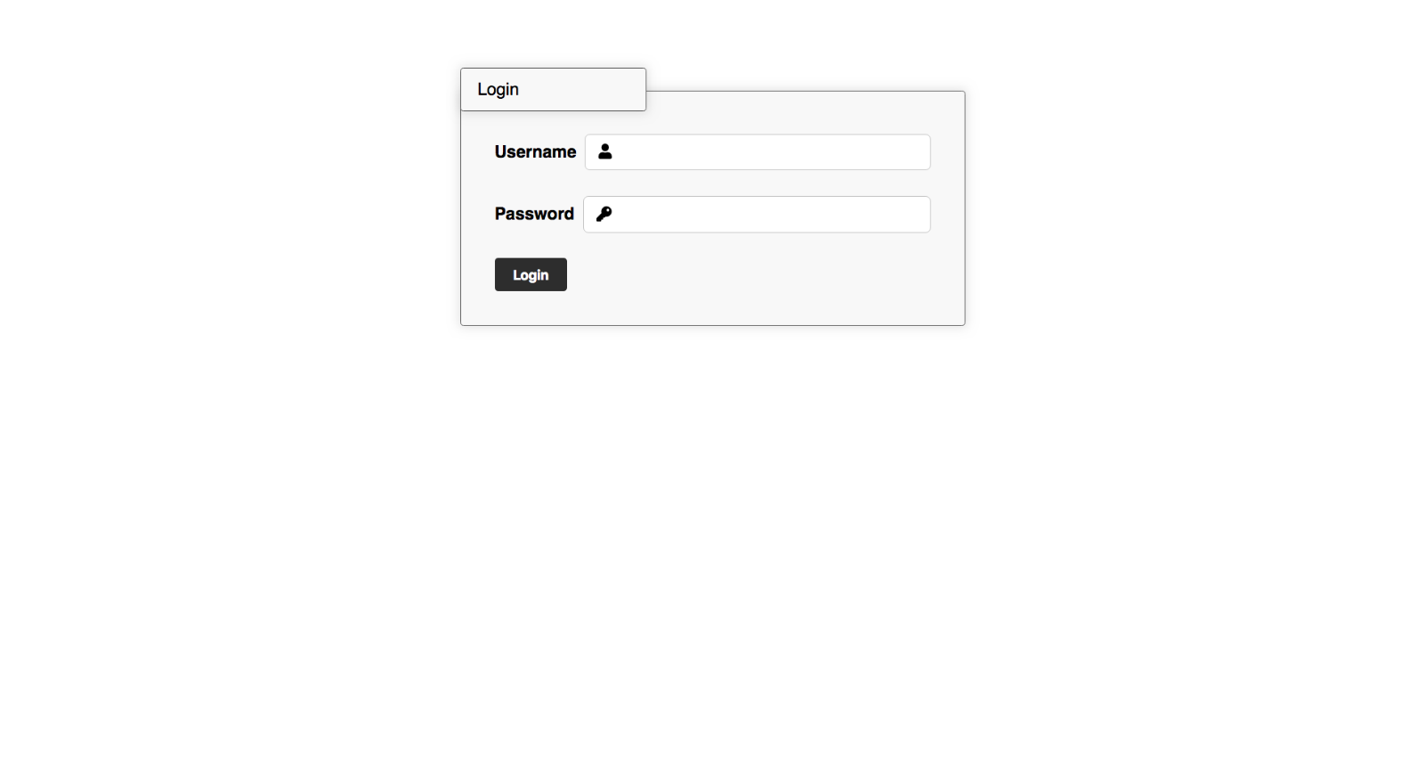

* Look at the provided screenshots in **resources** **folder** for different screen sizes view

### Constraints

* Change the document title to "**Responsive Forms**"
* Create a simple login form using **semantic** html
  + Add icons to the input fields using **FontAwesome**
  + Add focus state that changes the **input** and the **icon**

## Responsive Media Boxes

Create a web page like the following:

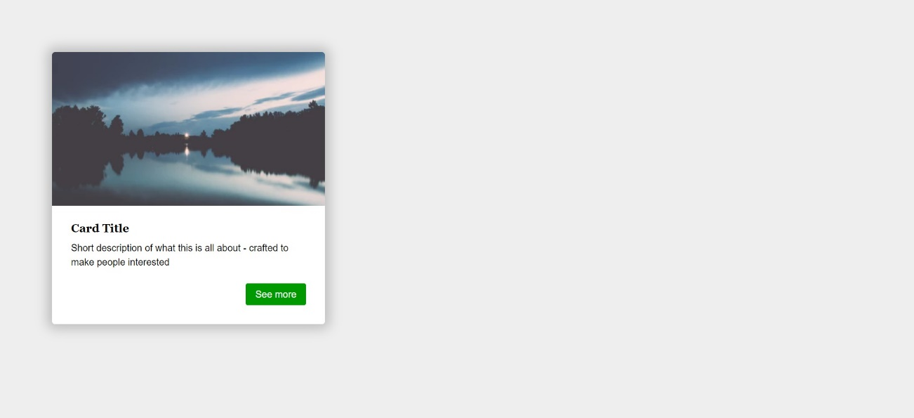

### Constraints

* Change the document title to "**Responsive Media Boxes**"
* Create a section with two div elements
* You can access the image [here](https://images.unsplash.com/photo-1538230942844-e89414a0692d?ixlib=rb-0.3.5&ixid=eyJhcHBfaWQiOjEyMDd9&s=34dcc54db235ce71b59c1d5ada02bdc4&auto=format&fit=crop&w=400&q=80)
* Use rgb(238, 238, 238) for body background
* Use rgb(255, 255, 255) for card background
* Use rgb(0, 153, 0) for card button background
* Use font Georgia, serif with size 1em/1.2 for the headings
* Use font Helvetica, sans-serif for the document

## Landing Page

Create a web page like the following:

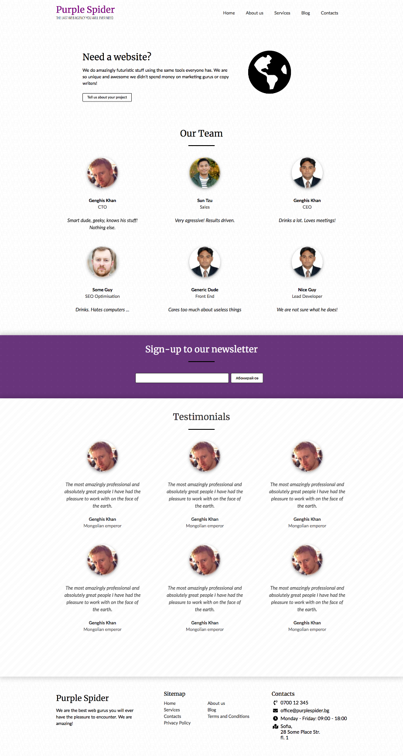

* Look at the provided screenshots in **resources** **folder** for different screen sizes view

### Constraints

* Change the document title to "**Landing Page**"
* Get the latest reset.css
* Get the latest typography.css
* Get the latest buttons.css
* Get the latest forms.css
* Create a section with a title Need a website?
* Create a section with a title Our Team
* Create a section with a title Sign-up to our Newsletter
* Create a section with a title Testimonials
* Create a footer
* Make the page **responsive** per the screenshots attached

## Responsive Tables

Create a web page like the following:

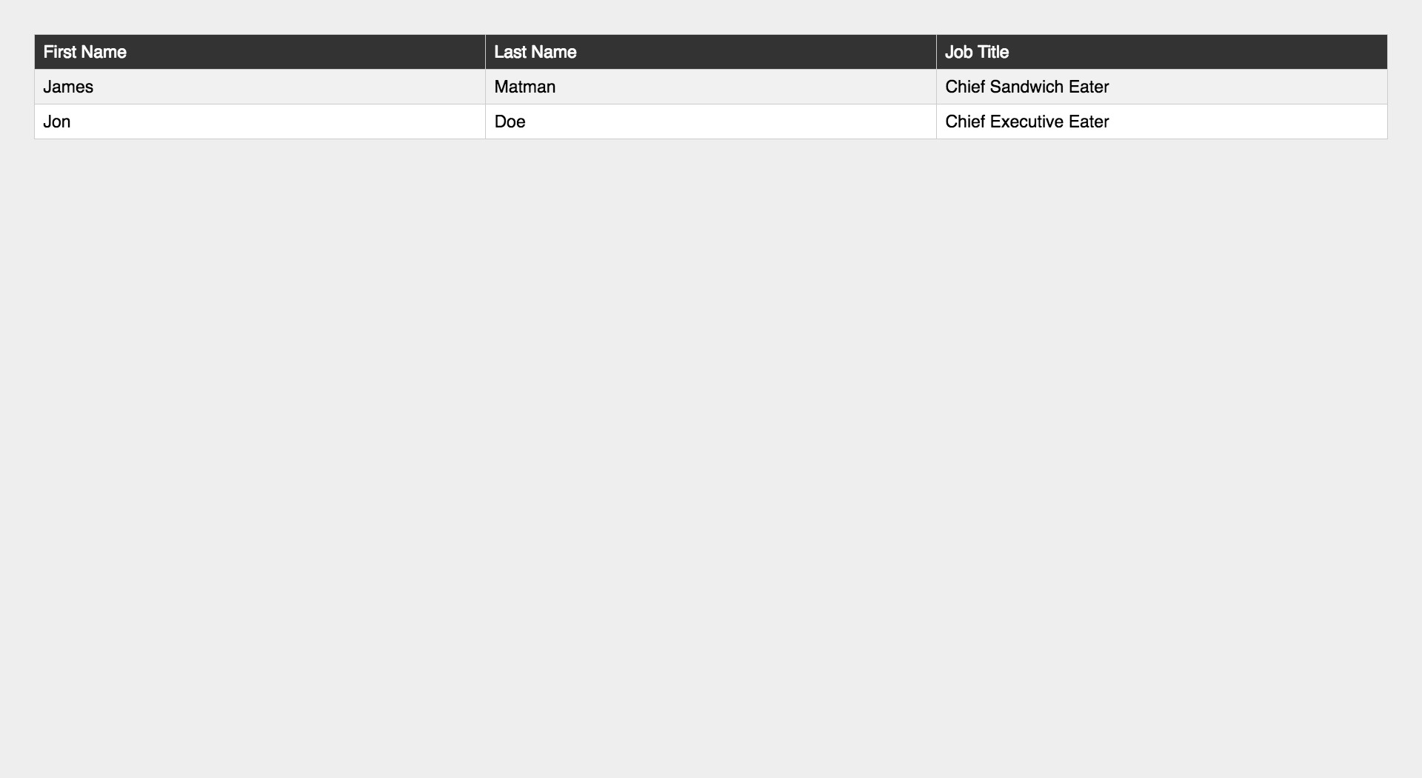

* Look at the provided screenshots in **resources** **folder** for different screen sizes view

### Constraints

* Change the document title to "**Responsive Tables**"
* Create a table with 3 columns: First Name, Last Name, Job Title
* Get the latest reset.css
* Get the latest typography.css
* Make the table **responsive**

## Responsive Vertical Timeline

Create a web page like the following:

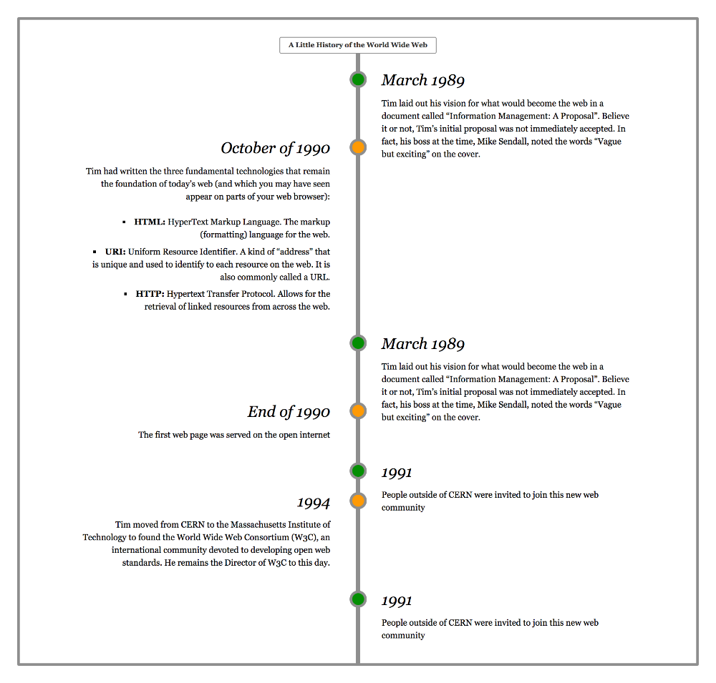

* Look at the provided screenshots in **resources** **folder** for different screen sizes view

### Constraints

* Change the document title to "**Responsive Vertical Timeline**"
* Create a section with class timeline
  + The section must have
    - Border width - 0.3rem
    - Border color - rgb(153, 153, 153)
    - Border style - solid
* Create seven articles (article) in the section
  + Divide **article content** into header and section
  + The header has h3 heading and the section has a paragraph with text inside
  + Style h3 font to italic
* Add media queries for the list to look good on **mobile** and **desktop**